3. (a) The diagrams below shows leaves obtained from five different plants.

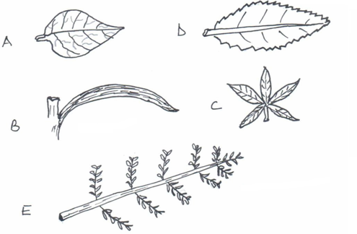

Using the key provided identify the plants from which the leaves were obtained in each case give the sequence of steps in the key which you followed to arrive at the identify.

1 (a) Leaf simple -------------------------------------------------------------- go to 2

(b) Leaf compound ---------------------------------------------------------------- go to 4

2. (a) Leaf with parallel veins------------------------------------------------------- Maize

(b) Leaf with network vein ------------------------------------------------------- go to 3

3. (a) Leaf margin smooth ---------------------------------------------------- Bou gainvillea

(b) Leaf margin serrated ---------------------------------------------------------- Hibiscus

4. (a) Leaflets emerging from one stalk like fingers ------------------------ Bombax

(b) Leaflets emerging from several stalk attached to main stalk-------- Acacia

|  |  |  |  |
| --- | --- | --- | --- |
| Leaf | Steps | Identity |  |
| A |  |  |  |
| B |  |  |  |
| C |  |  |  |
| D |  |  |  |
| E |  |  | (10 marks) |

1. State **three** differences between the classes from which leaf A and leaf B were obtained from. (3 marks)